STATIC WEBSITE HOSTING USING AMAZON S3 WITH CI/CD

Prepared in the partial fulfillment of the Summer Internship Program on AWS

AT


Under the guidance of

Mrs. Bethala Sumana, APSSDC Mr.Juttuka Lovababu, APSSDC Submitted by
GOSWAMI TITHI, 23B81A1265, CRRE ELURU, (Batch -2)

UPPUTHOLLA NEELAM RAJU,23B81A12H9,CRRE ELURU, (Batch -2)

VIJJAGIRI KOTAIAH,23B81A12I9, CRRE ELURU (Batch -2)

SURABATHINI BALAJI,23B81A12H2, CRRE ELURU (Batch -2)

SUDAGANI GANESH,23B81A12H1, CRRE ELURU (Batch -2)

PINISETTI ESWARI AYYAPPA NAGA SATYA SRI,23B81A12E6, CRRE ELURU(Batch-2)

ACKNOWLEDGEMENT

I would like to express my heartfelt gratitude to all those who have contributed to the successful completion of my summer internship project at Andhra Pradesh Skill Development Corporation (APSSDC). This opportunity has been an enriching and transformative experience for me, and I am truly thankful for the support, guidance, and encouragement I have received along the way.
First and foremost, I extend my sincere regards to Mrs Sumana Bethala and Mr.Juttuka Lovababu, my supervisors and mentors, for providing me with valuable insights, constant guidance, and unwavering support throughout the duration of the internship. Their expertise and encouragement have been instrumental in shaping the direction of this project.
I would like to thank the entire team at Andhra Pradesh Skill Development Corporation (APSSDC) for fostering a collaborative and innovative environment. The camaraderie, knowledge sharing, and feedback I received from my colleagues significantly contributed to the development and success of this project.
In conclusion, I am honoured to have been a part of this internship program, and I look forward to leveraging the skills and knowledge gained to contribute positively to future endeavours.
Thank you. Sincerely,
Goswami Tithi, 23B81A1265, goswamitithi1005@gmail.com.
Upputholla Neelam Raju, 23B81A12H9, neelamraju289@gmail.com.
Vijjagiri Kotaiah, 23B81A12I9, kotivijjigiri@gmail.com.
Surabathini Balaji, 23B81A12H2,balajisurabathini45@gmail.com.
Sudagani Ganesh, 23B81A12H1, ganeshss14354@gmail.com.
Pinisetti Eswari Ayyappa Naga Satya Sri, 23B81A12E6, satyapinisetty22@gmail.com.

ABSTRACT
The Know Your Rights website is a cloud-based web application developed to promote awareness of the Fundamental Rights guaranteed by the Constitution of India. The primary objective of this project is to provide citizens, students, and the general public with a simple, reliable, and user-friendly platform for accessing constitutional information. The website presents legal content in a structured format, making it easier for users to understand their rights and encouraging greater legal awareness.
The application is developed using HTML, CSS, and JavaScript for the frontend and deployed using a serverless architecture on Amazon Web Services (AWS). The website is hosted on Amazon Simple Storage Service (Amazon S3), while Amazon CloudFront is used to improve website performance by delivering content through a global Content Delivery Network (CDN). Backend processing is implemented using AWS Lambda, which executes serverless functions in response to user requests. Amazon API Gateway enables secure communication between the frontend and backend by exposing RESTful API endpoints. The legal information displayed on the website is stored in Amazon DynamoDB, providing fast, scalable, and highly available data storage. Amazon CloudWatch is used to monitor application performance, maintain execution logs, and assist in troubleshooting.
The integration of these AWS services provides a secure, scalable, and cost-effective cloud-native solution without the need to manage traditional servers. The application demonstrates the practical use of serverless computing for developing educational web applications while ensuring high availability, reliability, and efficient resource utilization.
Overall, the Know Your Rights website serves as an effective platform for improving constitutional awareness and demonstrates the successful implementation of modern cloud technologies using AWS services. The project highlights how serverless architecture can be utilized to build responsive, reliable, and future-ready web applications that benefit society.
Keywords: Know Your Rights, Fundamental Rights, Amazon Web Services (AWS), Amazon S3, Amazon CloudFront, AWS Lambda, Amazon API Gateway, Amazon DynamoDB, Amazon CloudWatch, Serverless Architecture, Cloud Computing, Legal Awareness.
TABLE OF CONTENTS

S.No Content Pg.No
- INTRODUCTION……………………………………………………………………....6
- METHODOLOGY………………………………………………………………………7
- TECHNOLOGY STACK……………………………………………………………..10
- SYSTEM DESIGN / ARCHITECTURE……………………………………………...12
- IMPLEMENTATION…………………………………………………………………21
- RESULTS……………………………………………………………………………..23
- CONCLUSION………………………………………………………………………...25

1.INTRODUCTION

The Know Your Rights website is a cloud-based web application developed to promote legal awareness by providing citizens with accurate and organized information about the Fundamental Rights guaranteed by the Constitution of India. The primary objective of this project is to create a simple, accessible, and user-friendly platform that enables students, citizens, and individuals from all sections of society to understand their constitutional rights without relying on multiple sources of information. By presenting legal content in a structured and easy-to-understand format, the application encourages awareness of fundamental rights and strengthens public understanding of constitutional values.
The application is built using modern web technologies and deployed on Amazon Web Services (AWS) using a serverless architecture. The frontend of the website is hosted on Amazon Simple Storage Service (Amazon S3), which provides secure, highly durable, and scalable storage for static web content. To improve website performance and reduce loading time for users across different geographical locations, Amazon CloudFront is used as the Content Delivery Network (CDN), ensuring fast and reliable content delivery.
The backend functionality of the application is implemented using AWS Lambda, where serverless functions process user requests and retrieve legal information without requiring dedicated servers. These functions are securely integrated with Amazon API Gateway, which acts as the communication layer between the frontend and backend by exposing RESTful API endpoints. The legal information, including Fundamental Rights and related constitutional details, is stored in Amazon DynamoDB, a fully managed NoSQL database that provides high availability, low-latency data access, and automatic scalability.
To ensure reliable application monitoring and troubleshooting, Amazon CloudWatch is used to collect execution logs and monitor the performance of backend services. The integration of these AWS services provides a scalable, cost-effective, secure, and highly available cloud-native architecture that minimizes infrastructure management while maximizing system reliability.
The Know Your Rights website demonstrates the practical application of cloud computing and serverless technologies in developing an educational platform that improves legal awareness and makes constitutional information easily accessible to the public. The project showcases how modern AWS services can be integrated to build a responsive, efficient, and future-ready web application capable of serving users with high performance and reliability.

2.METHODOLOGY

The development of the Know Your Rights website followed a systematic and cloud-native methodology to ensure the successful implementation of a secure, scalable, and user-friendly web application. The project was developed in multiple phases, including requirement analysis, system design, frontend development, cloud deployment, backend implementation, database integration, testing, and monitoring. Each phase was carefully planned to achieve the project objectives while utilizing the serverless capabilities of Amazon Web Services (AWS). The following subsections describe each phase in detail.

2.1 Requirements Analysis

The first phase of the project involved identifying the functional and technical requirements of the application. The primary objective was to develop a web-based platform that provides citizens with easy access to information about Fundamental Rights under the Constitution of India. The application was designed to offer a simple user interface, quick response time, and reliable access to legal information while minimizing infrastructure management through cloud computing.

During this phase, the AWS services required for the project were identified. Amazon S3 was selected for static website hosting, Amazon CloudFront for content delivery, AWS Lambda for backend processing, Amazon API Gateway for API communication, Amazon DynamoDB for storing legal information, and Amazon CloudWatch for monitoring application performance.

2.2 System Design
Based on the project requirements, a serverless system architecture was designed using Amazon Web Services (AWS). The architecture separates the application into frontend, backend, API, and database components.
The frontend is hosted on Amazon S3 and distributed through Amazon CloudFront. Whenever users request legal information, the frontend communicates with Amazon API Gateway, which securely invokes AWS Lambda functions. The Lambda functions retrieve the required data from Amazon DynamoDB and return the response to the website. Amazon CloudWatch continuously records logs and monitors the execution of backend services.
This architecture provides high availability, scalability, and reduced operational complexity.
2.3 Frontend Development
The frontend of the Know Your Rights website was developed using HTML, CSS, and JavaScript. The interface was designed to be simple, responsive, and easy to navigate for users of different age groups and technical backgrounds.
The website includes multiple pages containing information about Fundamental Rights, Constitutional Articles, legal awareness content, and other educational resources. Special attention was given to responsive web design so that the application functions effectively on desktop computers, tablets, and mobile devices.
2.4 Cloud Deployment
After completing the frontend development, the website files were uploaded to Amazon S3, where Static Website Hosting was enabled. To improve website performance and reduce latency, Amazon CloudFront was configured to distribute the website content globally.
This deployment strategy ensures that users receive faster page loading times while benefiting from the scalability and reliability of AWS cloud infrastructure.

2.5 Backend Implementation
The backend functionality was implemented using AWS Lambda. Serverless functions were developed in Python to process incoming API requests and retrieve legal information from the database.
Instead of maintaining traditional web servers, AWS Lambda automatically executes backend code whenever requests are received from Amazon API Gateway. This serverless approach reduces infrastructure management and improves resource utilization.

2.6 Database Integration
The legal information displayed on the website is stored in Amazon DynamoDB, a fully managed NoSQL database service. The database contains information related to Fundamental Rights and constitutional provisions.
Whenever users request information from the website, AWS Lambda retrieves the corresponding records from Amazon DynamoDB and sends them back to the frontend through Amazon API Gateway. This integration provides fast data retrieval and supports future scalability.
2.7 Testing and Monitoring
After completing the development and deployment phases, the application was thoroughly tested to verify the functionality of each AWS service and the communication between system components. The frontend, backend APIs, Lambda functions, and database operations were tested to ensure accurate data retrieval and proper website functionality.
Application monitoring was performed using Amazon CloudWatch, which records Lambda execution logs and helps identify runtime errors or performance issues. Continuous monitoring ensures that the application remains stable, reliable, and ready for production use.

3. TECHNOLOGY STACK
The Know Your Rights website was developed using modern web technologies and deployed using Amazon Web Services (AWS) to provide a scalable, secure, and serverless cloud environment. The selected technology stack enables efficient frontend development, reliable backend processing, secure data storage, and continuous application monitoring. Each technology and AWS service was selected based on its capability to improve application performance, scalability, and ease of maintenance.
3.1 Frontend Technologies
The frontend of the Know Your Rights website was developed using standard web technologies to provide an interactive and responsive user interface. These technologies ensure compatibility across different web browsers and devices.
HTML5(Hyper Text Markup Language):
HTML5 was used to design the overall structure of the website. It provides semantic elements for organizing content such as navigation menus, headings, images, buttons, forms, and legal information displayed on the website.
CSS3 (Cascading Style Sheets):
CSS3 was used to enhance the visual appearance of the website by applying colors, layouts, typography, animations, and responsive design. It ensures that the application provides a consistent user experience on desktops, tablets, and mobile devices.
JavaScript:
JavaScript was used to implement interactive features within the website. It handles user interactions, communicates with backend APIs, processes responses received from the server, and dynamically displays legal information without requiring complete page reloads.

3.2 Cloud Platform
    - Amazon Web Services (AWS): The entire project is hosted on AWS, leveraging its serverless services for storage, computation, database management, and notifications.

AWS Services

- Amazon S3: Used for storing input CSV files. Triggers Lambda functions on file uploads.
- Amazon CloudFront: is used as the Content Delivery Network (CDN) for the application. It distributes website content through edge locations across different geographical regions, reducing latency and improving page loading speed.
- AWS Lambda: Executes the core business logic — parsing files, processing data, updating the database, and triggering notifications.
- Amazon API Gateway acts as the communication layer between the frontend and backend services. It receives HTTP requests from the website, invokes AWS Lambda, and returns the processed responses to users securely.
- Amazon DynamoDB: NoSQL database for storing product names, quantities, and timestamps. Offers fast and scalable access to inventory records.
- Amazon CloudWatch is used to monitor backend services and record execution logs generated by AWS Lambda. It assists in troubleshooting, debugging, and monitoring application performance.

3.4 Programming Language

Python
The backend logic of the application is implemented using Python within AWS Lambda. Python was selected because of its simplicity, readability, and seamless integration with AWS services.
3.5 Architecture Type
The Know Your Rights website follows a Serverless Architecture, where backend processing is performed without maintaining physical or virtual servers. AWS automatically manages resource allocation, scaling, and infrastructure, allowing developers to focus entirely on application functionality.
The serverless architecture improves scalability, availability, security, and cost efficiency while minimizing operational overhead.

4. SYSTEM DESIGN / ARCHITECTURE
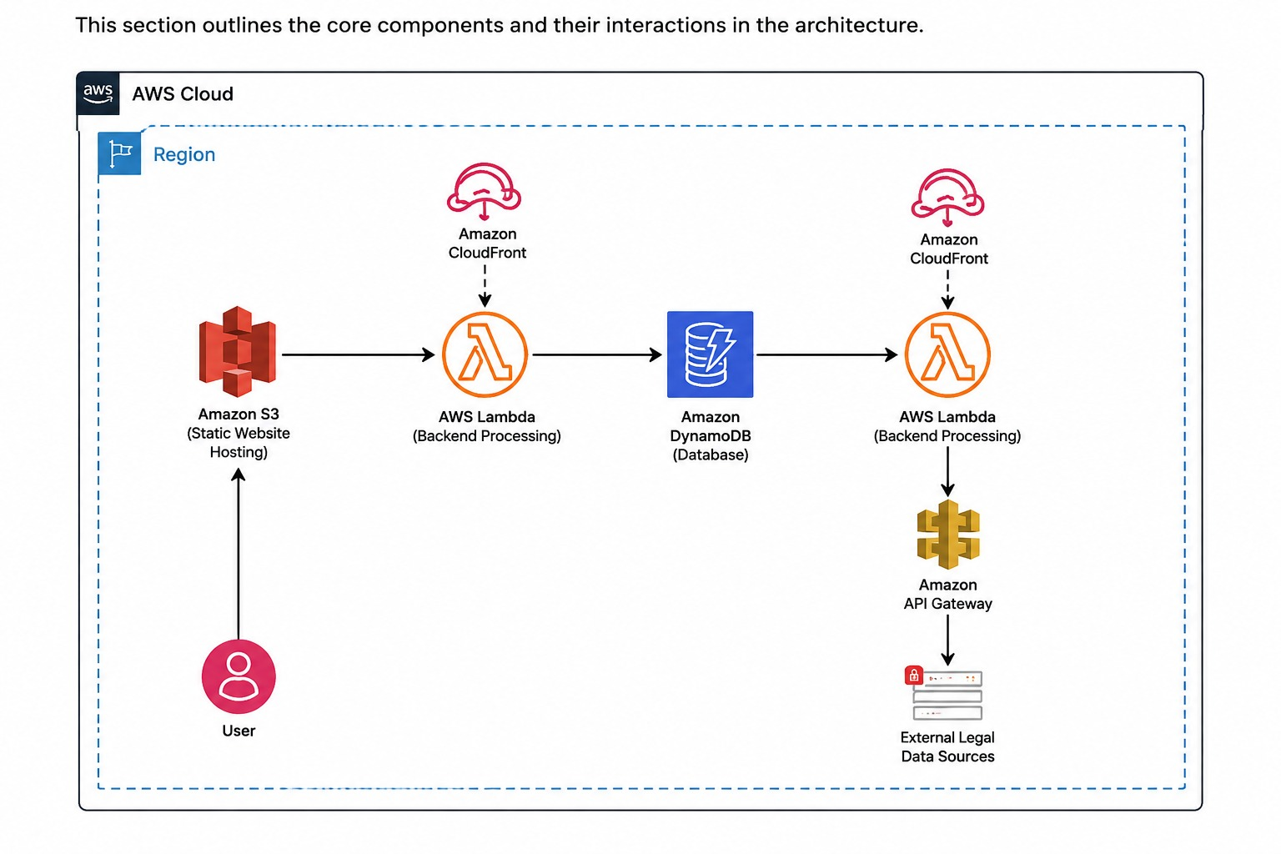

Data Ingestion Layer – Amazon S3:

Amazon Simple Storage Service (Amazon S3) is used to host the frontend of the Know Your Rights website. All static website files, including HTML, CSS, JavaScript, images, and icons, are stored securely in an S3 bucket. Static Website Hosting is enabled to make the website publicly accessible through the internet. Amazon S3 provides high durability, scalability, and reliable storage, making it an ideal solution for hosting static web applications

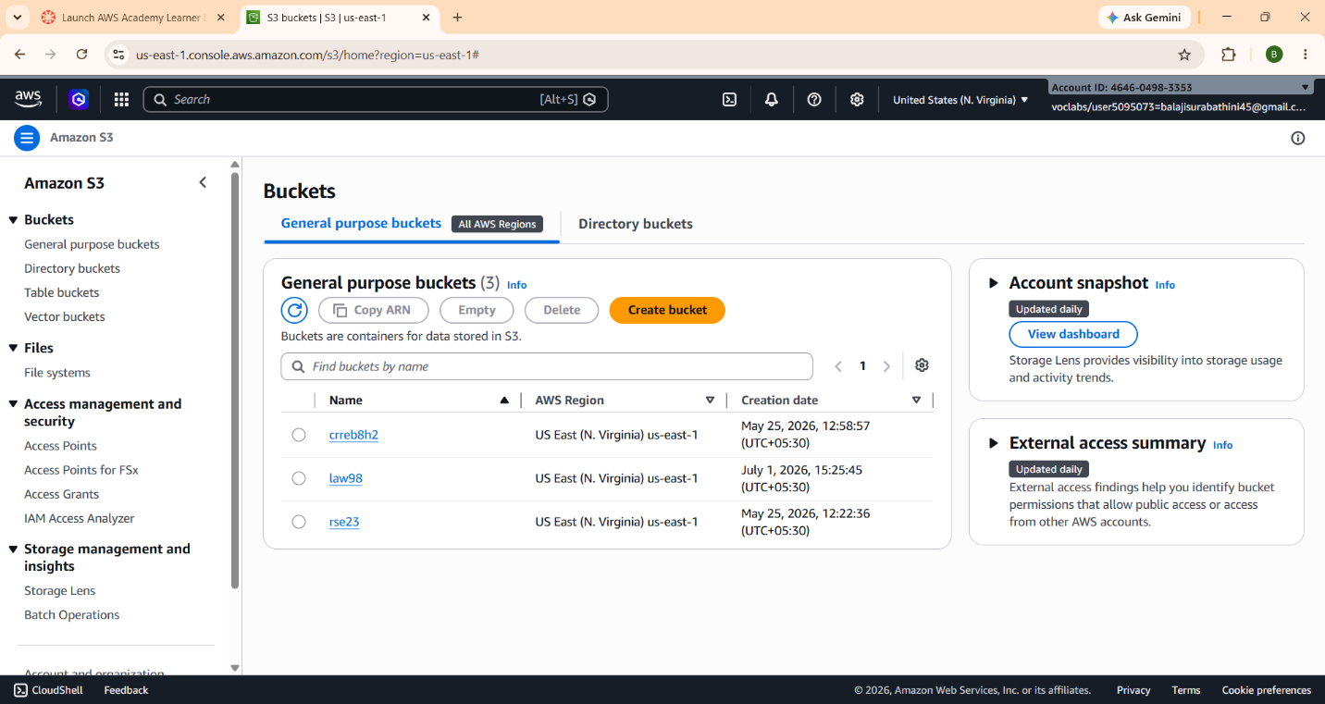

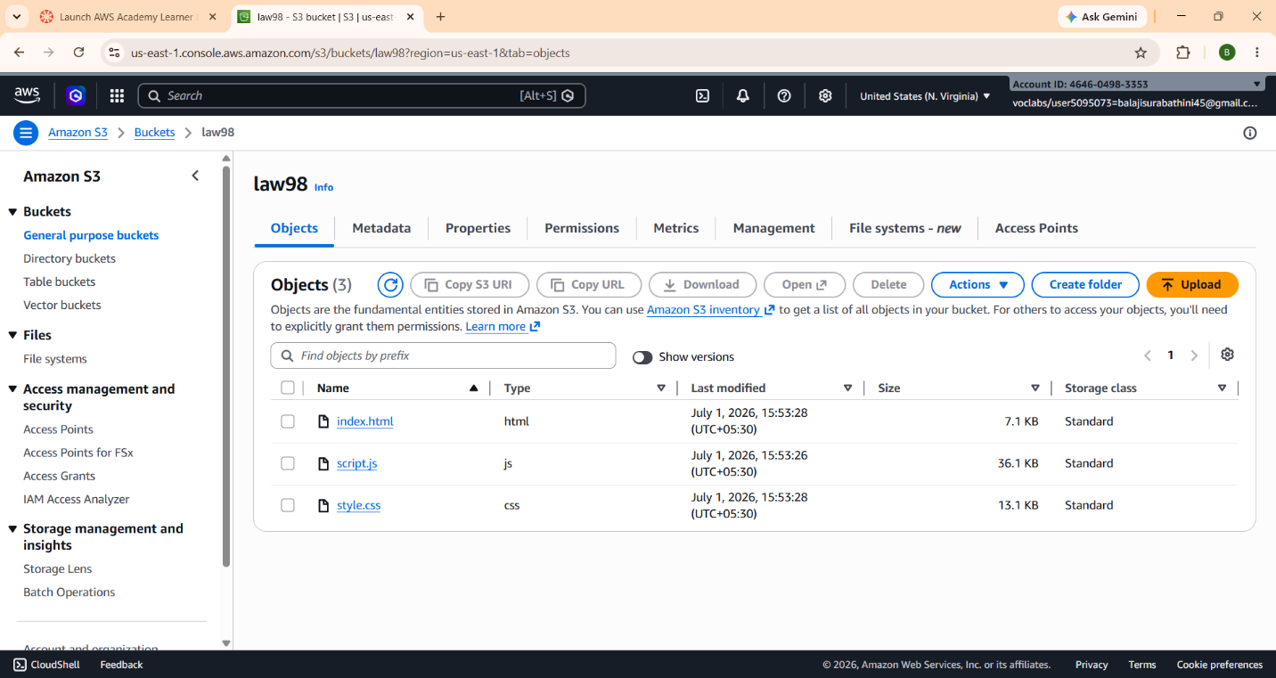

  - Amazon CloudFront:
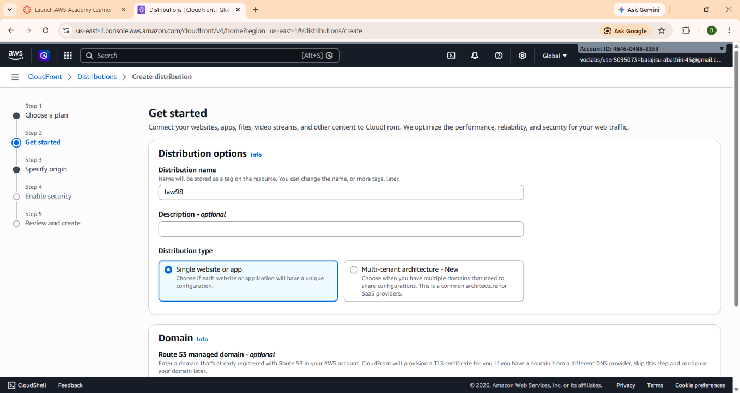
Amazon CloudFront is configured as the Content Delivery Network (CDN) for the website. It distributes the website content through AWS edge locations located across different geographical regions. This significantly reduces latency, improves website loading speed, and provides users with a faster browsing experience. CloudFront also enhances security by supporting HTTPS connections and secure content delivery.

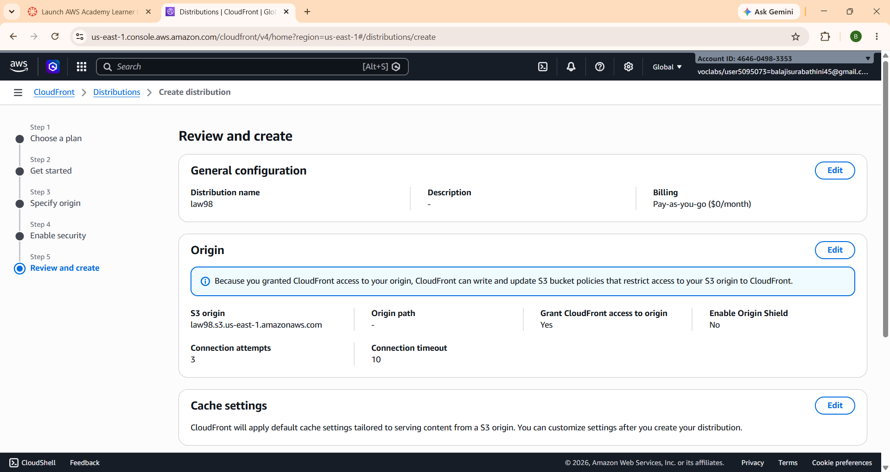

  - AWS Lambda: AWS Lambda is used to implement the backend logic of the application. It processes API requests, retrieves legal information from the database, and returns the response without requiring dedicated servers.

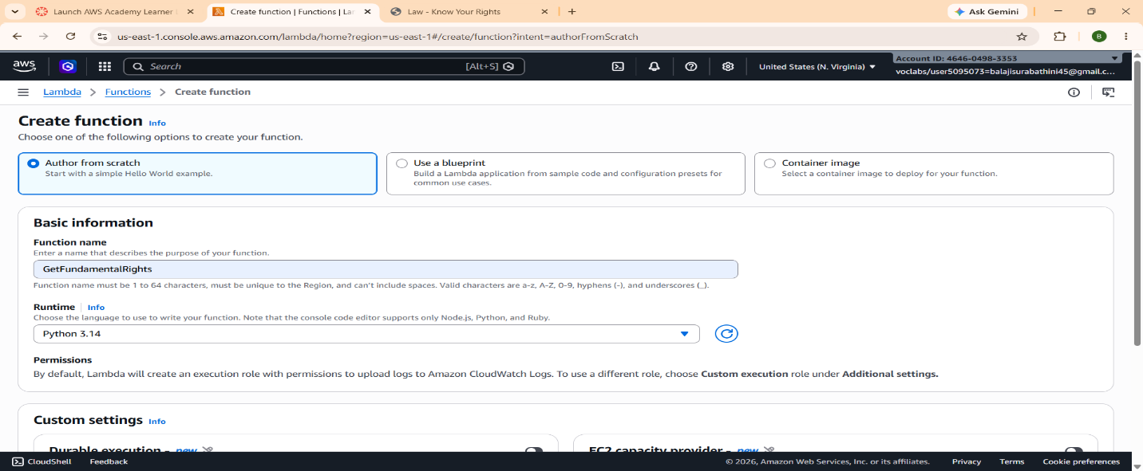
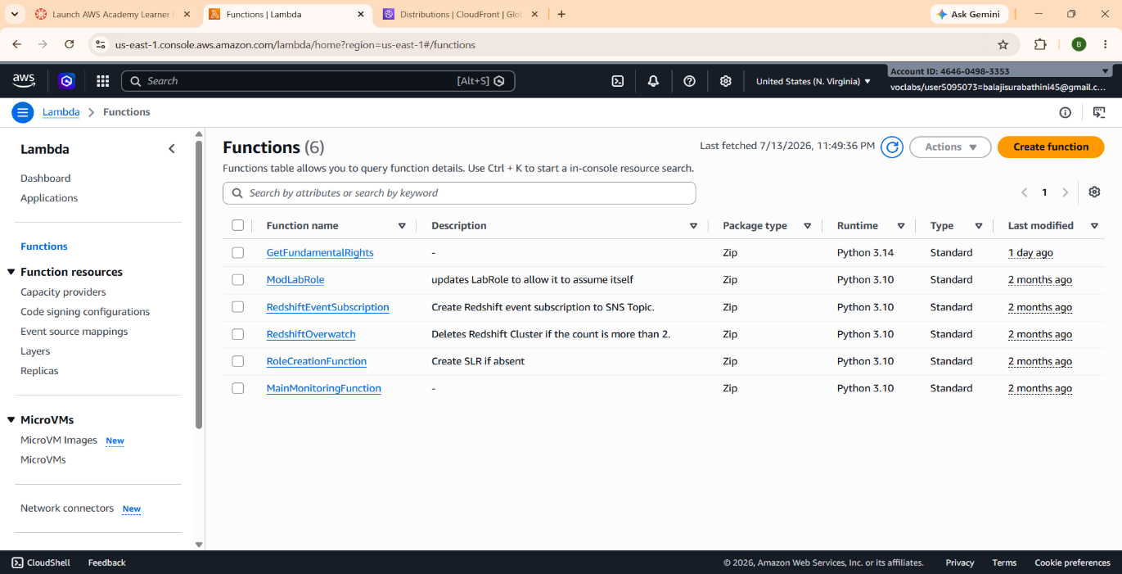
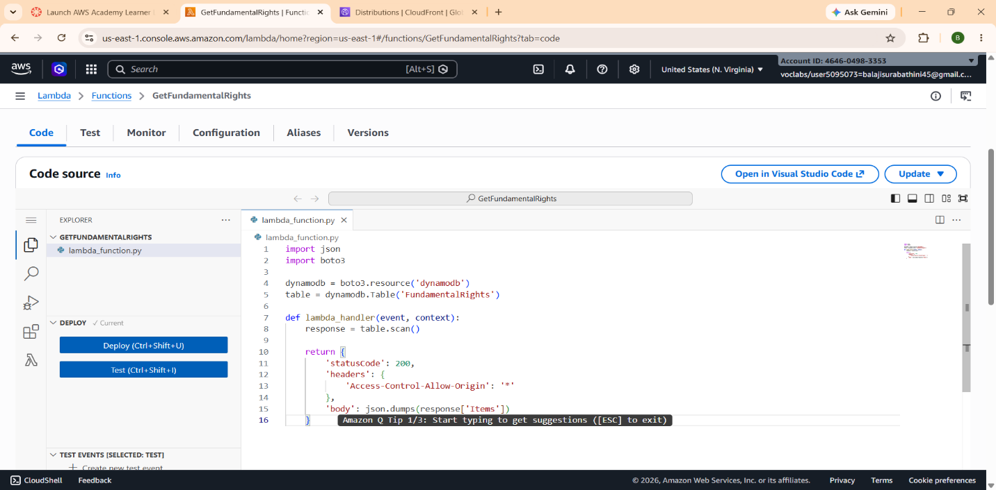

  - Amazon API Gateway:
Amazon API Gateway receives HTTP requests from the website and securely invokes AWS Lambda functions. It acts as the communication layer between the frontend and backend services.
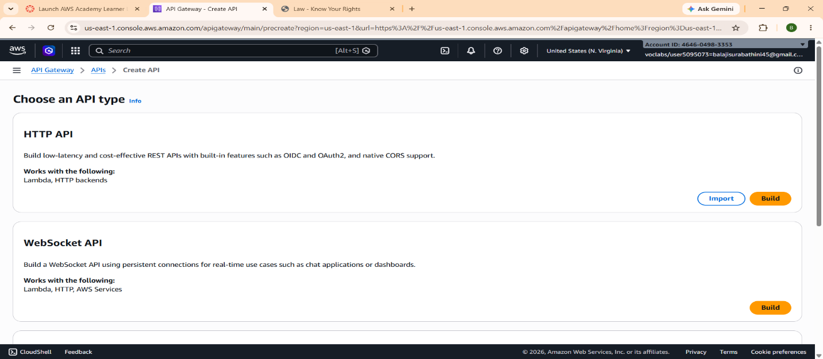
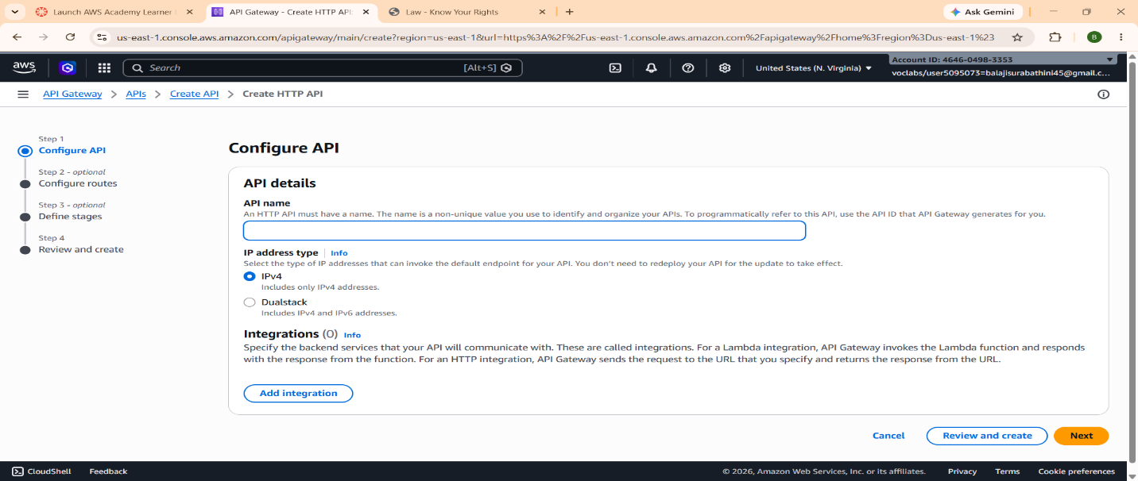
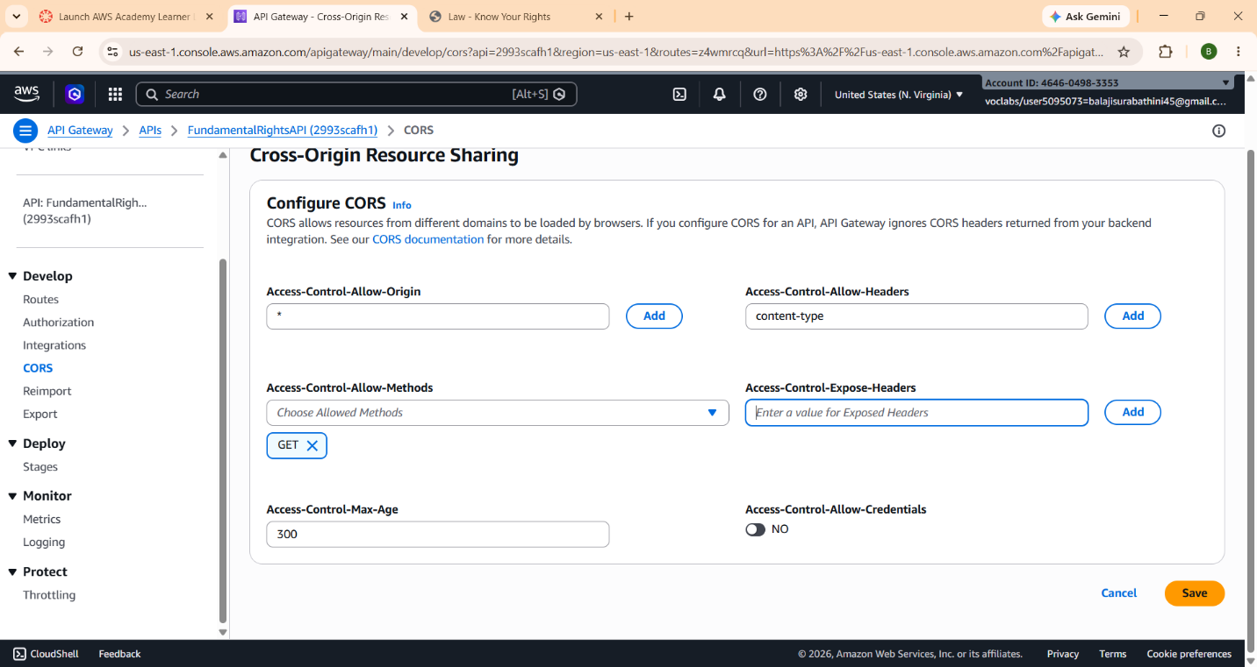

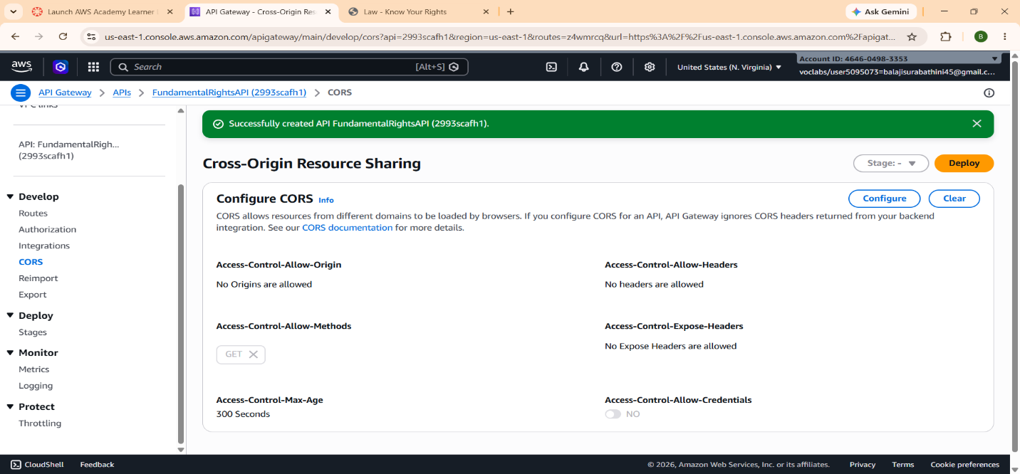

  - Amazon DynamoDB:
Amazon DynamoDB is used to store information related to Fundamental Rights and constitutional articles. It provides fast, scalable, and highly available NoSQL database services.

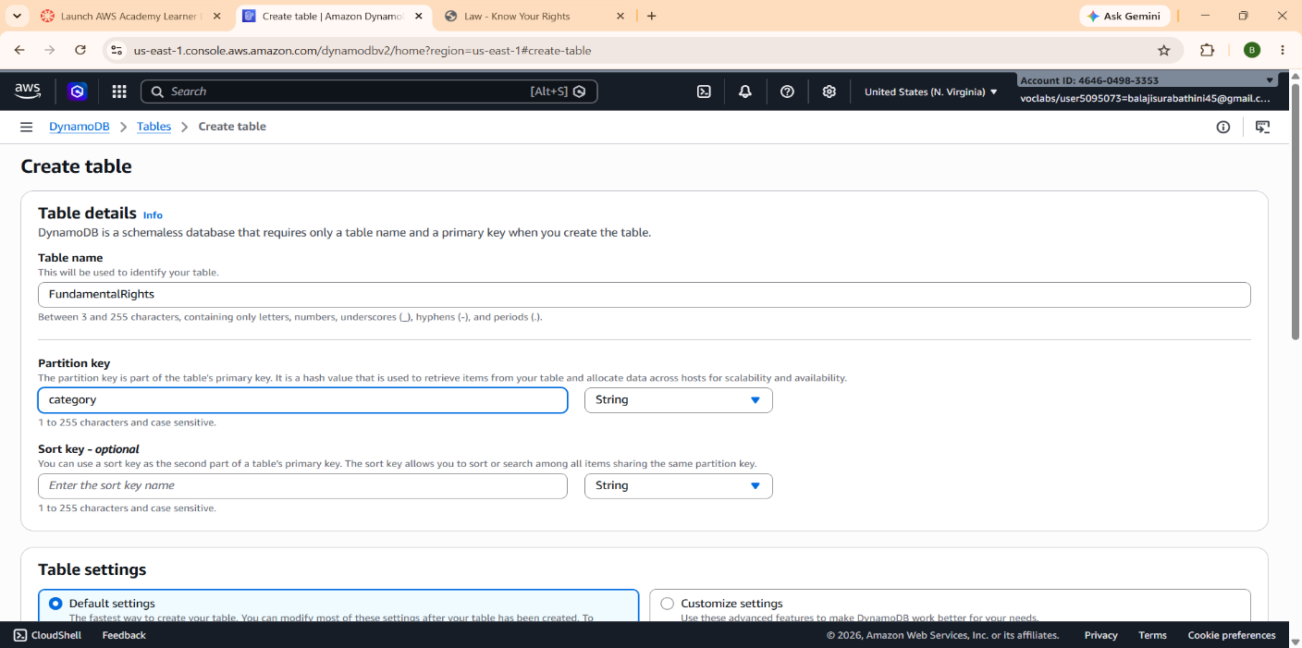
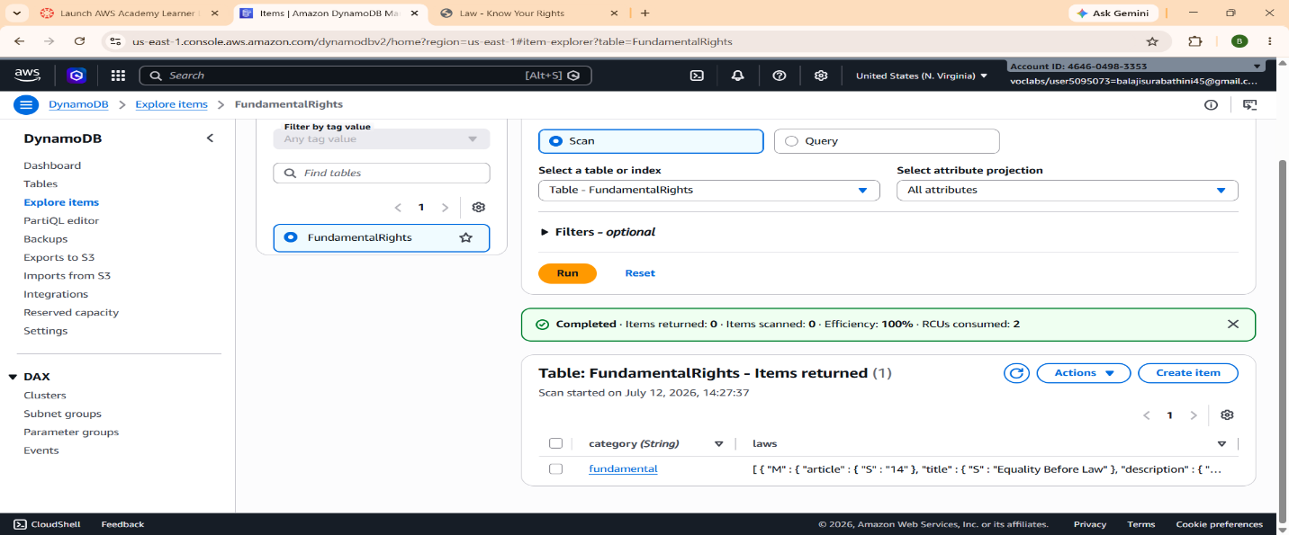

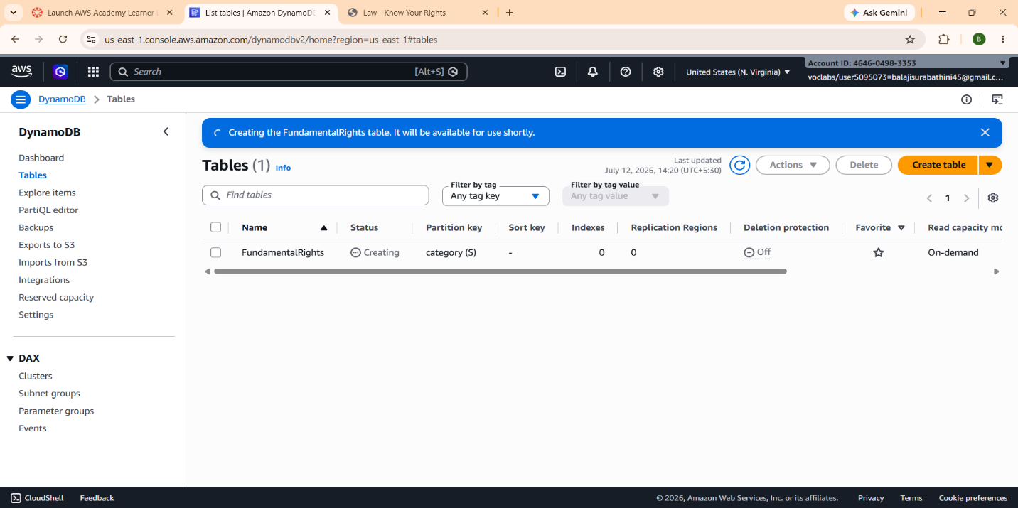

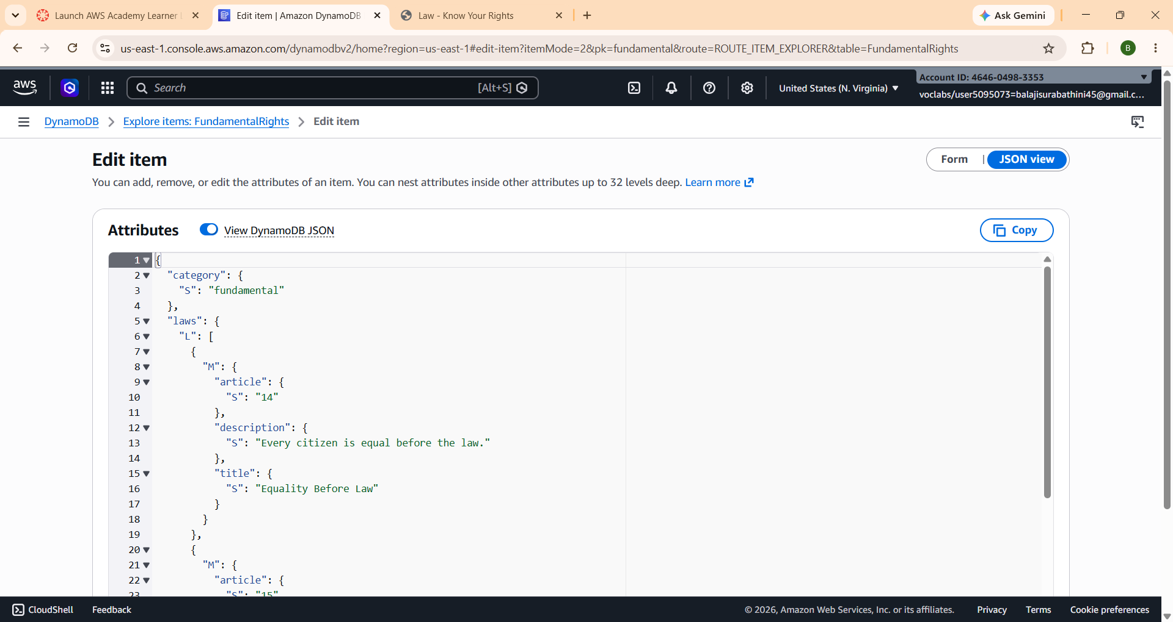

4.6 Amazon CloudWatch:
Amazon CloudWatch monitors the performance of AWS Lambda functions and records execution logs. It helps identify errors and ensures the reliable operation of the application.

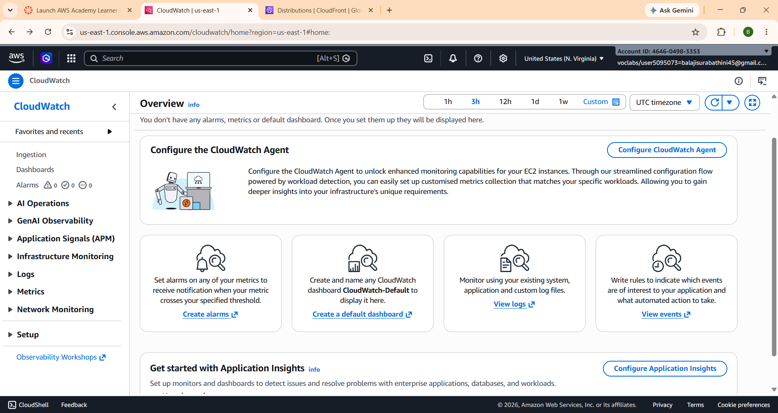

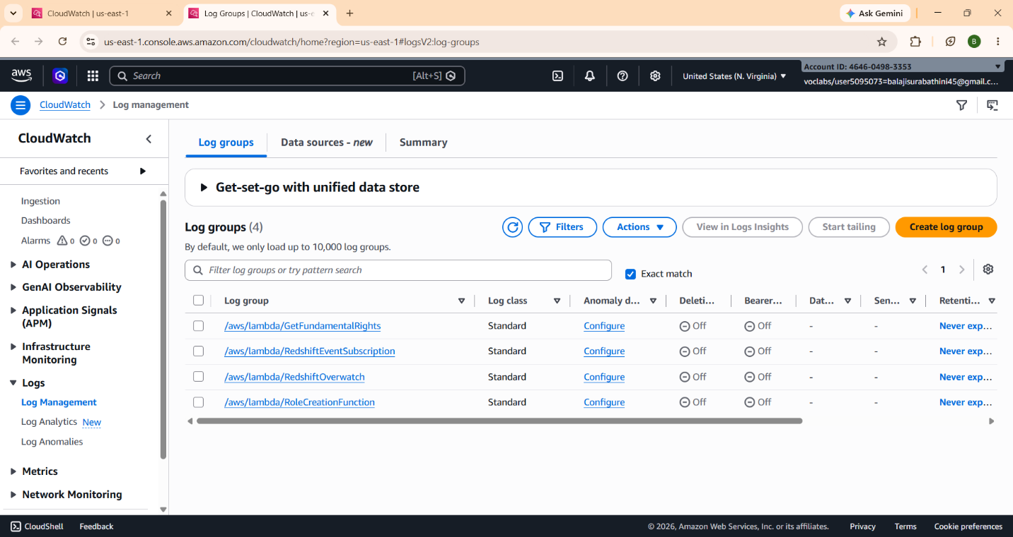
OUT PUT :

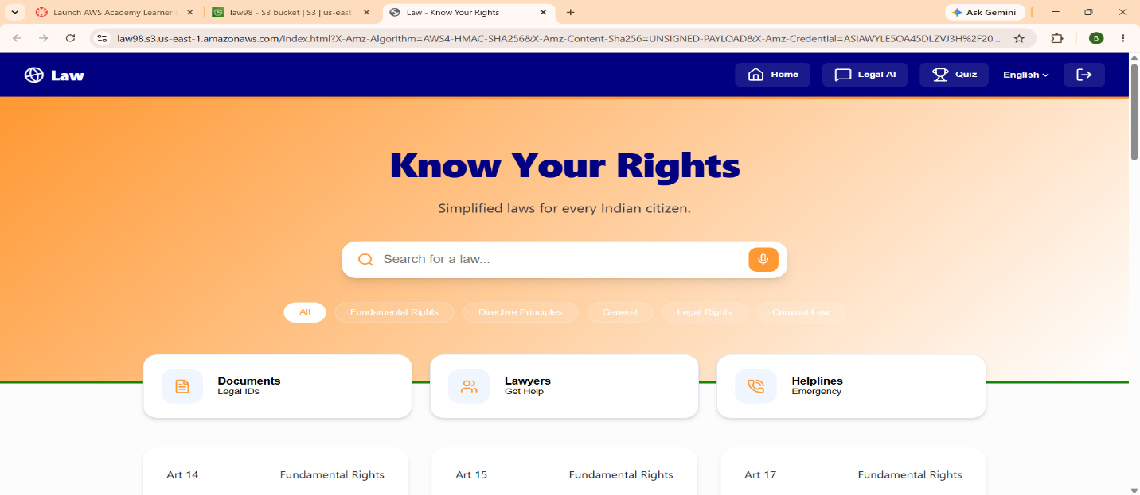
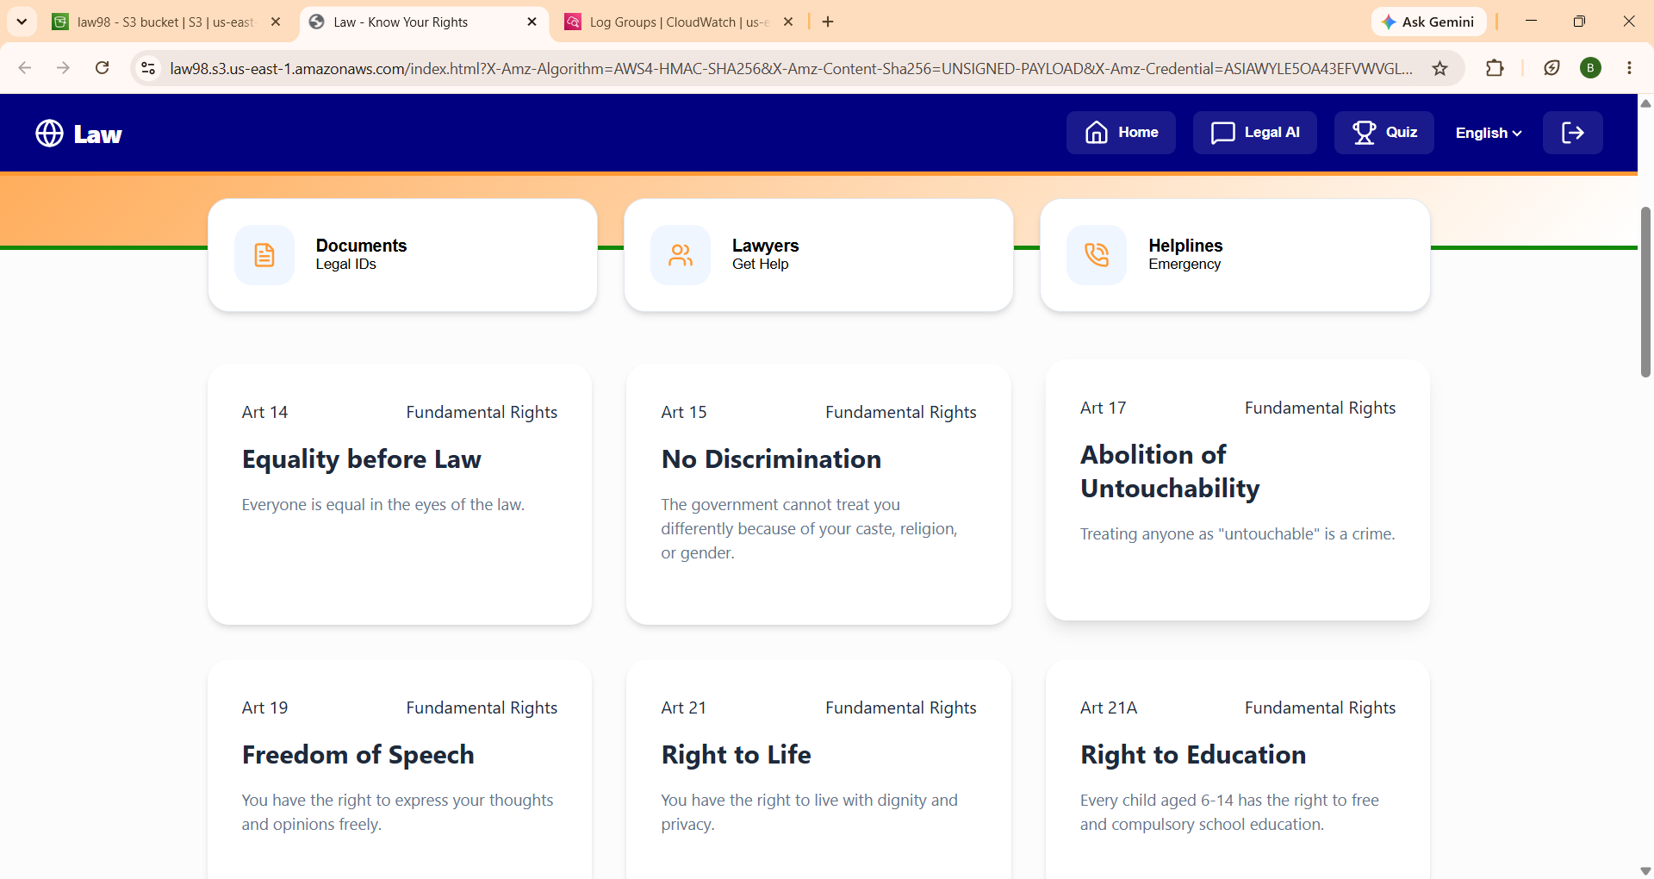
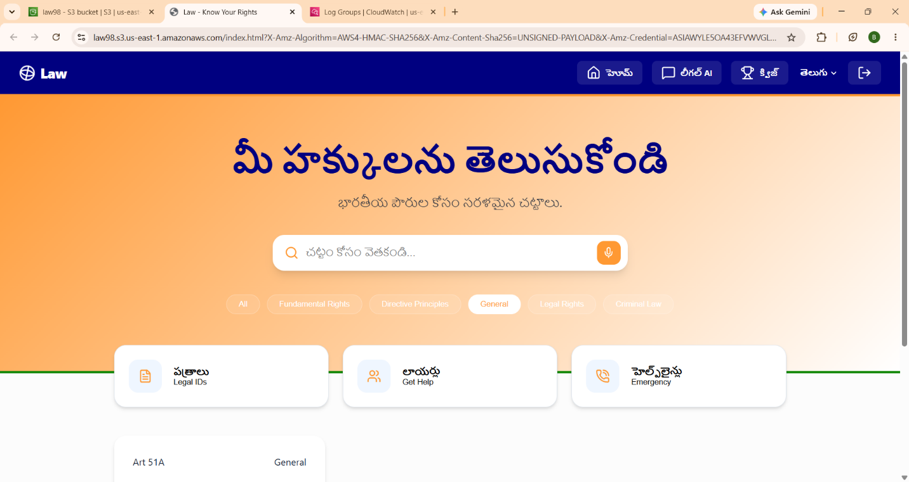
5. IMPLEMENTATION
The implementation phase of the Know Your Rights website focused on developing and deploying a cloud-based serverless web application using Amazon Web Services (AWS). The project was implemented by integrating frontend technologies with AWS cloud services to create a secure, scalable, and highly available application. Each AWS service performs a specific role in the overall architecture, ensuring smooth communication between the frontend and backend components.
5.1 Frontend Development and Website Hosting
The frontend of the Know Your Rights website was developed using HTML, CSS, and JavaScript. The website includes multiple pages containing information about Fundamental Rights, constitutional articles, and legal awareness. After development, all frontend files were uploaded to Amazon Simple Storage Service (Amazon S3).
Static Website Hosting was enabled in the S3 bucket, allowing users to access the application through a web browser. Bucket permissions were configured to provide secure public access to the website resources.
5.2 Content Delivery using Amazon CloudFront
To improve website performance, Amazon CloudFront was configured with the S3 bucket as its origin. CloudFront distributes website content through AWS edge locations, reducing latency and improving loading speed.
Using CloudFront also enables secure HTTPS communication and provides better performance for users accessing the website from different locations.
5.3 Backend Development using AWS Lambda
The backend functionality of the application was implemented using AWS Lambda. A Python-based Lambda function was created to process API requests received from the frontend.
The function retrieves legal information from Amazon DynamoDB, converts the data into JSON format, and returns it to the application. Since Lambda is a serverless service, AWS automatically manages execution and scaling without requiring dedicated servers.
5.4 API Integration using Amazon API Gateway
Amazon API Gateway was configured to expose REST endpoints for the application. The API receives HTTP GET requests from the website and forwards them to the corresponding Lambda function.
Cross-Origin Resource Sharing (CORS) was enabled to allow secure communication between the frontend hosted on Amazon S3 and the backend services.
After processing the request, the API Gateway returns the response to the frontend in JSON format.
5.5 Data Storage using Amazon DynamoDB
Legal information used by the application is stored in Amazon DynamoDB. The database contains records related to Fundamental Rights and constitutional information.
Whenever a user requests information through the website, the Lambda function accesses DynamoDB, retrieves the required records, and sends the response back through the API Gateway.
The NoSQL architecture of DynamoDB provides high performance, automatic scaling, and low-latency data retrieval.
5.6 Monitoring using Amazon CloudWatch
Application monitoring was performed using Amazon CloudWatch. Lambda execution logs, response times, and error information were automatically recorded in CloudWatch.
This service helped verify successful execution of Lambda functions and simplified debugging during development and testing.
5.7 Integration Workflow
The complete implementation follows a serverless workflow. Users first access the website hosted on Amazon S3 through Amazon CloudFront. When legal information is requested, the frontend sends an HTTP request to Amazon API Gateway. The API Gateway invokes the appropriate AWS Lambda function, which retrieves data from Amazon DynamoDB. The processed response is then returned to the frontend and displayed to the user. Throughout this process, Amazon CloudWatch monitors backend execution and records application logs.
6. RESULTS
The Know Your Rights website was successfully developed and deployed using Amazon Web Services (AWS). The application was tested to verify the functionality of each integrated cloud service and ensure smooth communication between the frontend, backend, and database components.
The website was successfully hosted using Amazon S3, while Amazon CloudFront improved content delivery speed and reduced page loading time. Users were able to access the application through a secure web interface without installation or additional software.
The backend services implemented using AWS Lambda successfully processed API requests and retrieved legal information stored in Amazon DynamoDB. Amazon API Gateway efficiently handled communication between the frontend and backend, ensuring reliable data transfer.
Testing confirmed that the application correctly retrieved and displayed legal information related to Fundamental Rights. The serverless architecture provided automatic scalability and minimized infrastructure management.
Application monitoring through Amazon CloudWatch confirmed successful execution of Lambda functions and helped identify execution logs during testing.
Overall, the application achieved its objectives by providing a secure, responsive, and cloud-based platform for accessing constitutional information.
6.1 Achieved Results
- Successfully hosted the frontend using Amazon S3.
- Improved website performance using Amazon CloudFront.
- Developed a serverless backend using AWS Lambda.
- Established secure API communication through Amazon API Gateway.
- Stored legal information in Amazon DynamoDB.
- Monitored application performance using Amazon CloudWatch.
- Successfully displayed constitutional information through the website.

Figure 6.1: Website Home Page


Figure 6.2: Website Output

7. CONCLUSION
The Know Your Rights website was successfully designed, developed, and deployed as a cloud-based web application using Amazon Web Services (AWS). The primary objective of the project was to create an easy-to-use platform that provides citizens with reliable information about the Fundamental Rights guaranteed by the Constitution of India. By presenting constitutional information in a simple and organized manner, the website helps improve legal awareness and encourages citizens to better understand their rights and responsibilities.
The project effectively demonstrates the practical implementation of a serverless architecture using AWS cloud services. Amazon Simple Storage Service (Amazon S3) was used to host the static website, while Amazon CloudFront ensured fast and secure content delivery to users. AWS Lambda handled backend processing without requiring dedicated servers, and Amazon API Gateway enabled secure communication between the frontend and backend services. Legal information was stored efficiently in Amazon DynamoDB, and Amazon CloudWatch was used to monitor application performance and maintain execution logs.
The integration of these AWS services resulted in a scalable, reliable, and cost-effective cloud solution with minimal infrastructure management. The application successfully retrieves and displays legal information through a responsive web interface, providing users with a smooth and efficient browsing experience.
The Know Your Rights website serves as a practical example of applying cloud computing technologies to develop an educational platform for legal awareness. The project not only strengthened knowledge of AWS serverless services and modern web development but also demonstrated how cloud technologies can be used to build meaningful applications that benefit society. In the future, the application can be enhanced by introducing multilingual support, advanced search functionality, AI-based legal assistance, and additional constitutional resources to make legal information even more accessible to a wider audience.

